# Return to Chaos

A light glows around you like white fire.

***Play Catacombs***

When it disperses, you are standing in the cellar of a Temple. You see dinner cloths and robes sewn with an emblem. The emblem is a circle of seven stars.

Religion check to realize its for Mystra, Goddess of Magic. The cellar is dusty and dust collects on nearly every surface. Cob webs decorate the walls, but the spiders have long since left. There are a 3 full flasks of what looks like water with the circle of stars on it, as well as 6 empty flasks laying in front of the door. 4 are cracked.

A skeleton lies on the floor, cuddling an empty bottle of wine. It is wearing robes with the circle of stars on it.

There is a stair case that leads to a wooden door. The door looks to be cracked, as if someone tried to bust in.

*The door is locked.* (but the key is in the robes of the skeleton)

The cellar opens up into a long stone hallway. The walls and door are gouged with deep scratches, and the floor is spotted with small, dry red dots.

It is brisk and cold in the cellar. So much so that you can see your breath.

The hallway stretches out, showing 2 doors on either side of the hallway, with a wrought iron spiral staircase leading upward at the end of the cellar.

Say: *it doesn’t look like this room has anything useful*

One room has a bunch of broken wine bottles.

One room is completely empty, except for a holy symbol on the wall, a mat with the circle of stars on the floor, and an incense burner.

One room has a few cots stacked on top of each other, for storage.

***It appears as if there is a large cat wearing clothing sleeping on top of one.***

One room has a few Mystra prayer books stacked on a desk.

The spiral stair case leads up to a platform with a blue door.

The door opens up into a sanctuary with a nave attached. The candles, unlit and dusty, are completely melted down, leaving wax piles on the unkept floor. The pews, the alter and floor look to be unused for quite some time. 2 skeletons lay in pieces on the sanctuary, and dried blood is smeared around.

The door leading outside is piled up with pews and anything else heavy.

If they inspect the room, they will feel a small breeze coming from the opposite side of the alter, which leads to an open door. Otherwise, they can just go out the front by moving all the shit.

# Silver Rose

***Play Haunted Town Creepy Ambience***

The city of Silver Rose looks to be destroyed. Houses have burned down or have been ripped apart. Others have candle light glowing out of cracks in boarded up windows. Ice is struggling to survive in the shadows under the winter sun. You can still see your breath in the brisk air. You may not be dressed for the occasion.

You recognize this as the northern most part of town, close to the exit you took to go to Serenity Garden. You can hear signs of life, but the streets appear empty.

**What do you do?**

You do see life in the city. Most people you talk to are weary of you, but trust the ‘human’ wearing the holy symbol. They will ask you for help lifting a board, holding it level, or nailing it in.

“The undead happened. They keep coming in hoards. The first attack was 7 years ago. Our best soldiers and city watch were able to keep them out of the city, but at a great cost. The second attack was worse. By the 3rd attack, we barely had any soldiers to protect us. I couldn’t even tell you how many undead came through those gates…. everyone died…or was eaten. Those of us that remain have cellars to hide in. But even that isn’t enough these days…”

A strong odor of urine, body odor, and other unpleasant smells overwhelms your senses.

“YOU DIDN’T BELIEVE ME ABOUT JERGAL!” a sudden yellow erupts from behind you. It is the old lady from your first visit to Silver Rose. Her ratted white hair and yellow teeth look worse than before, if that’s even possible. “I told you this devil was trouble *velhalla*. And now we will all die! You should pray to jergal. Maybe he’ll just let you die rather than allow that bitch to turn you into a puppet.”

*will talk about Jergal. Her name is Tulip.*

## Silver Vine Inn

The inn is full of people. The doors have been coated in steel and a thick gate has been put up around the entry way. Two guards stand watch over the gate.

“Who goes there!” One of the guards shout, holding a spear towards the gate.

**Wait for response**

Mary Margaret and David are dead.

The other guard is younger. His name is Christopher. He was 11 when you rescued him from the sewer (now 18). He welcomes you inside.

Elis and Cindy disappeared about 5 years ago.

The food is mostly rationed at this point. They offer you small cups of soup and a small piece of bread. Barely enough to fill your stomach. They tell you how hard finding food has been lately.

You recognize Rejak, from Richochet Armaments. The enormous man is helping haul large iron bars upstairs. The rooms upstairs are open to the outside so they are gating them up.

Overall, the inn still looks well-kept. It’s obvious the residents are taking the time to clean.

**What do you do?**

***Ella wants to go see Taoba***

## Talos Temple

This temple is very similar to Silver Vine. A large, tall gate has been constructed around the entirety of the circular building. There is no guard outside.

Upon walking up to it, Ella begins to play her lute, the one Nasoj gave to her in the Crystal Caverns, and signs. It takes a few minutes, but eventually Taoba comes running out.

“Ella, is it really you? And Ellena, and Velhalla! Where’s Nasoj? Who are these three?”

Taoba is spewing questions frantically as he struggles to open the gate. The Talos priest, still dressed in black robes with a lighting bolt sewn on, looks skinny, but healthy.

He talks about how Kallista came back years ago and said she had waited outside the Fey for weeks before assuming you were dead. She’s been joining up with fighting parties and going out to defend the city or find answers. Each time she returns, she returns alone and with fresh wounds. She’s been gone quite some time now. She is due back sooner or later, if she’s even alive.

He asks what you plan to do now?

*He offers to go with you.*

## Other

There is not a lot else to do in Silver Rose

# Next Steps:

Arynsport (The pegasi aren’t recommended for going over the mountain).

Demon’s Hearth

# Leaving Silver Rose:

The gates to Silver Rose are heavily mended, with loose pieces of iron or wood nailed over the gates to cover holes.

As you open the gate, you see the familiar silhouette of a rouge dressed in tight leather walking towards you. The leather is torn in several places, exposing deep cuts in the rogue’s pale skin. Despite her wounds, her glowing yellow eyes are as radiant as ever.

**What do you do?**

## Kallista

Kallista doesn’t seem happy to see your crew. She expresses minimal surprise that you’re still alive and disdain that you left her with a dwarf for weeks.

Thu’mer died, she thinks. She decided to leave long before he would even consider leaving Nasoj. But as she made her way to Silver Rose, a hoard of undead was making its way North. As a Rogue, she was able to sneak past them, but she doubts a clumsy, hot headed dwarf was able to survive.

She offers you a drink, and retrieves a couple bottles of blackberry wine from her leather back pack.

“I want to recruit your help,” she says, taking a large swig of the wine. The alcohol seems to be her safety blanket

“I don’t think the Talos temple, the one in the mountains, has lost its usefulness yet. The temple has been regarded as the most impenetrable temple in the world. Not only does the natural perils of the Storm’s Rage Mountains protect it, but Talos and other gods look over the mountains themselves. However, I don’t believe it was always a Temple to Talos. A shrine may have once existed in the mountains, worshiping a god of light and life, Lathander, and may hold a relic that can stop the undead.”

DC 18 to detect deception or DC 15 arcana check to question it or DC 20 arcana check to know that the Talos temple was built over a temple to Jergal, when Jergal was still god of death. When Myrkul (then Cyric, then Kelemvor) took over, the temple was abandoned and the clergy, known as the Scriveners of Doom, moved to an unknown location.

“I would appreciate your help, but we’ll move faster in a small group. Taoba has already agreed to come. Ella, can I count on you?”

Ella nods

“Velhalla, Ellena, how about you?”

“We’ve come so far. It will be nice to travel with a familiar face,” Velhalla says, smiling at the two pretty girls in front of her.

“Perfect. A warrior, a rouge, a bard, a forest dweller, and a cleric. What more could we need” she says, smiling.

*Say goodbyes as the other party leaves for the temple to get Taoba* *Will see if they can create or re-activate a transportation circle in the temple*

**Play Dark Tavern – Goblin King’s**

The Silent Plains now reflect their name more than ever before. The once green grass is now glazed with ice that reflects the light of the winter sun. The scarce trees that lightly dot the plains have grayed and abandoned their leaves for the winter. Their sleeping branches are lightly dusted with powdery snow.

The chilling wind bites at your faces, familiar only to Vincent who grew up in the White North region of the Storm’s Rage mountains. Even at it’s brightest, the sun struggles to break through the snow and ice.

**What do you do?**

# To Demon’s Hearth

Your walk is cold, but pretty. Overall, it is uneventful as the sun makes its way across the sky.

Find a place to begin to rest as the sun makes its final decent. Eat food.

The frost seems to be collecting more as the sun retreats. The bone chilling cold is beginning to take over your body. The long trudge in the cold has exhausted you.

*END OF DAY*

**What do you do?**

If sleeping, the sound of rapidly approaching footsteps awake you. You can see a large group of individuals charging in your direction. **What do you do?**

**Play Darkest Dungeon**

If in Plains, lots of zombies attack. (6 or 8 zombies, 2 Wight)

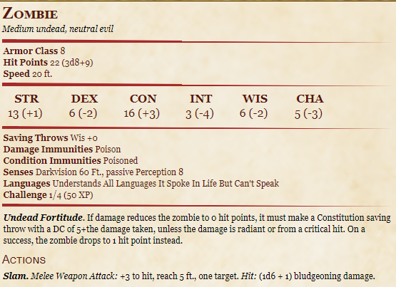

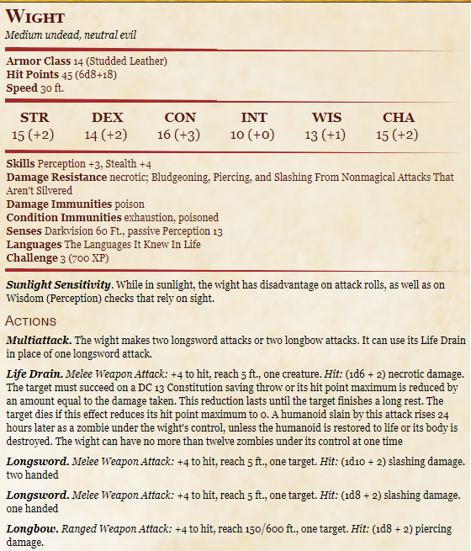 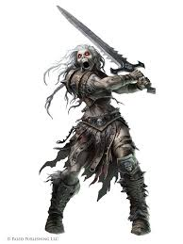

The [creature] shrieks in pain as it falls. The screams stretch across the Plains, like a call to arms from a fallen soldier. Your heart beats faster as the scream is answered in the distance in multiple directions.

**What do you do?**

Fight at least 3 more zombies and 1 more Wraith.

Off to the West, you can see a couple lights glowing off in the distance, very close together. It is probably over half a mile away, so you cannot make out what it is, even with dark vision.

**What do you do?**

## The Farm House

**Play Ravenia (it has a lead in so play it here not later)**

As you approach the lights, you realize that it is candle light coming from the windows of a farmhouse.

The light is barely lighting up a wooden fence with stakes pointed out, threatening anyone who dares run too close. A thundering *neigh* echos from in front of you. The largest horse you’ve ever seen gallops towards you, a hooded figure on its back. In front of you, a gate has opened in the wooden fence.

As you run, the horse rushes by you. You can feel the force of its movement as it cuts the air next to you.

The rider begins swinging a giant flail, lit ablaze, in vertical circles at their side. The giant, black horse plows fearlessly into the pack of undead behind you. The fiery flail knocks it’s enemies to the ground as the warhorse crushes their limbs and chest with it’s massive hooves. Black armor covering the mount protects it from the claws and teeth of the undead.

It’s not long till the pack is slain.

The rider turns their stead and lightly gallops back towards you. The flail rests at the ready in their hand, but the fire has dissipated. They are getting quite close.

**What do you do?**

### Artemis

The hooded rider, dressed in all black, stares down at you from the back of their horse. The horse’s back is easily 6ft off the ground. The rider’s face is wrapped in black cloth, hiding everything but their piercing eyes. You can see a fresh scar cutting over their right eye. Finally, the rider and the mount begin taking off inside the fence. They motion for you to join them.

As you walk into the rider closes the fence behind you. You can see the outline of vegetable and fruit beds leading up to the farmhouse.

The rider points at the farm house door, but takes their mount over to the stable.

**What do you do?**

The inside of the farmhouse is well kept. The windows have been reinforced with wrought iron, similar to those in Silver Rose. A pot is boiling over a well-lit fire. It is obviously stew, and it smells amazing.

The rider enters the room, their moonlight gray eyes staring suspiciously at you. They take off their cloak, revealing a slender but muscular silhouette standing about 5ft 4in tall. The bandages covering the rider’s face seem to wrap around the length of their body, as well.

The rider backs up slowly into their kitchen area and retrieves enough bowls for all of you, including the Boggle, plus themself. They put the bowls on the table, all the while keeping their eyes on you.

“How are you still alive?” They ask, muffled by the cloth. It is a girl’s voice. You can hear the weight of her pain in her breath.

Everyone in Willow’s Watch is dead. Her overly paranoid father taught her how to fight, how to grow crops, how to hunt, and how to do everything else she would ever need. He died protecting the farming village when the War of the Undead began. Her mother passed a few years after from disease.

Her community worshipped Chauntea (NG, Life, Sheaf of Grain emblem) goddess of agriculture. But her mother was from Demon’s Hearth and worshiped Pelor (NG, life and light, sun emblem) god of sun and healing. Before her mother passed, she prayed to Pelor to protect her daughter. The girl felt a calling to wonder into the desert. She found a stone baring ruins of ancient times. When she dug, she found a flail and black bandages.

The bandages make her immune to slashing or piercing damage, and if a wound is bandaged with them, it will stop you from dying but will not heal the wound.

It was a gift from Pelor.

Her name is Artemis. Her horse is Stranger. Artemis is very young and although she is very talented, she is also very scared.

She offers to let you sleep here for the night. She also says that the farming village of Willow’s Watch was decimated easily. Afterall, farmers aren’t made for fighting the undead. She says you should look through the village to see if there’s anything you could need.

*DAY BEGINS*

## Willow’s Watch

10 things of rations. Wool sweaters for everyone. 10cp, 12cp, 3sp, 1gp, and 5cp x 10. Crop seeds.

A single chicken comes walking up to you and stares at you expectantly.

The chicken will follow you for some time. EAT FOOD

## Day 2

*DAY ENDS*

Find shelter somewhere or else the zombies will strike again. EAT RATION

*DAY BEGINS*

## Day 3

About an hour into your day you begin to hear weird ticking noises, like a clock.

(if they roll a perception check DC 10) you notice a weird metal…mouth?...poking out of the ground. It quickly burrows back in and the ticking stops.

This happens again and again.

*mid day – eat*

As you begin to approach a hilly countryside, a much louder ticking can be heard. Suddenly, a large cobra slithers down a hill. But it is not a normal cobra. It is purple and appears to be made of metal.

The ticking gets louder and louder as the cobra moves towards you, it begins to hiss but the his is very mechanized.

More ticking begins to join in as several of the bronze-metal mouths being popping up out of the ground, reveling large mechanical worms x7. THEY DO NOT ATTACK WILLUM!

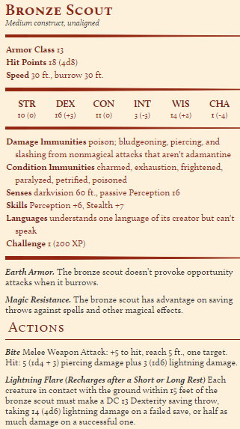**What do you do?**

## Rivvenastorp

After your run in with these strange creatures, you find yourself in a strange but magical village. Tiny houses residing in the hills are quaint and fun. It is still chilly, and the grass at the bottom of the hills are lightly covered in ice. It is nowhere near as cold as in Silver Rose, however.

Lots of gnomes walking around. They all stare at you funny.

Direct to Zimzankatan. Zim created the monsters to protect from the undead. However, he couldn’t really get them to ONLY target the undead, so they settled for ignoring gnomes instead…He’s peeved that you broke their security feature.

You can buy some interesting things. And stay the night.

*DAY ENDS*

# Demon’s Hearth

*DAY BEGINS* *EAT*

The ice is completely gone as the fertile soil begins to turn to sand, but the chill in the air still lingers. Quickly, as you walk, the sand turns soft and nearly white, swirling in small tornados in front of you.

You can go South-West to the Tiefling village and potentially Sandstone.

You can go South to the Desert of Dragon’s (dragonborn community)

You can go South-East in search of the temple ruins.

### Abydos – Tiefling Village

It is over near the southern Storm’s Rage mountains.

The walk is long and uneventful. Even cactus don’t reside in this part of desert. The sand is soft and hard to walk in and gets in your boots and pretty much everywhere else.

As the sun begins to set, you begin to hear the howls of wild dogs. The way the sound carries over the sand is eerie, but nothing unexplainable.

It has been another log day of walking. The desert, although the frost of winter has no power here, is rapidly getting colder as the sun begins to set. Discomfort sets in at the temperature change and your empty stomachs beg for food. You are still 2 hours away from the village.

**What do you do?**

You can hear creatures moving around your party. Low grows begin to surround you.

Suddenly, a large, black dog charges at you. It’s massive, muscular body is only overshadowed by the fact that it has two large, snarling heads. One of the heads is missing an ear.

The creature lunging at you invites the others to do so as well. You count 7 of these dogs. (Alpha has more HP and +1 attack and const).

Notes: If you throw your rations, it will go away.

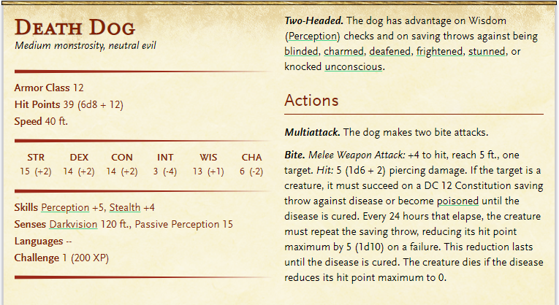

The village is carved out of the red mountain rock in a desert cove. Carved stair cases, worn from the years, lead up half a dozen levels. Windows and doors are left open with only cloth and thin wooden panels protecting from wandering eyes and sand.

In the center of the cove is a bazaar. Open air vendors offer the strangest foods, such as bread as black as night, cactus fruits in pinks and oranges, pies cooked like dumplings with strangely spiced meats, and roasted duck on spits.

Tieflings of all regards are wondering through the town. Some are so pale they look nearly human, while others are so dark red they are nearly black until the sun hits their skin. Black hair, purple hair, and red hair seem to be the most common, and horns of all types and shapes are decorated proudly.

There are all sorts of people on the street other than the vendors

1. Children playing with dragon wood dolls (speak infernal only)
   1. Tell you that brass dragons and blue dragons live in the desert, even though no one has seen them. Brass dragons are nice, but blue dragons are mean.
   2. Blue dragons will eat you but brass dragons would rather trade.
2. A man wearing bones yelling something in infernal
   1. A witch doctor. Will sell you a potions that:
      1. Rots your flesh and makes you appear undead forever, but your insides are unaffected (6gp)
      2. A Feign Death scroll (lv 3 spell, 500gp)
         1. You make someone appear dead for 1 hr
         2. Need a pinch of graveyard dirt (V, S, M)
         3. Target is blind and incapacitated
         4. Resisted to everything but psychic damage
3. 3 different groups talking in the streets
   1. None will speak to you and look at you with disgust
4. A woman who is eyeballing you
   1. She asks if you are adventurers
   2. She asks if you can find her locket. Some bandits took it years ago.
   3. Says she has a reward if you bring it to her
      1. Have a reward that relates to the story somehow.

You may stay at the inn for normal pricing

### Desert of Dragons

The Desert of Dragons is quite far. (do same dog scenario if they did this first and not Abydos).

You can see a large, natural, red-stone wall in front of you; a smaller mountain range branching off from Storm’s Rage. You cannot see either end of them.

**What do you do?**

Balsimar remembers there is a valley that goes through it.

Long story short, during the day you are attacked by a pack of Gnolls (hyena-headed humans). Not enough to kill them all but enough to weaken them. The sun begins to go down and the Gnolls suddenly pull back. Que 2nd wave of undead Gnolls.

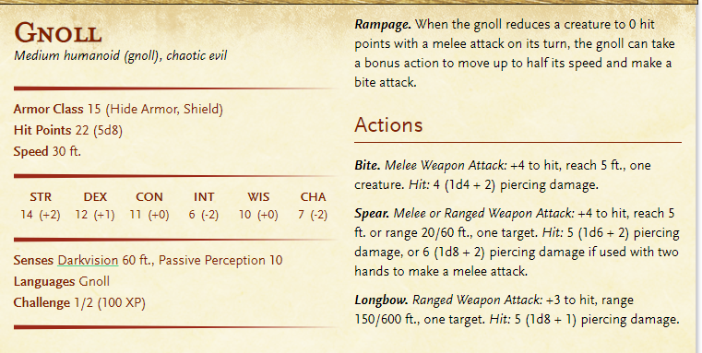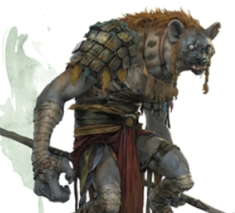

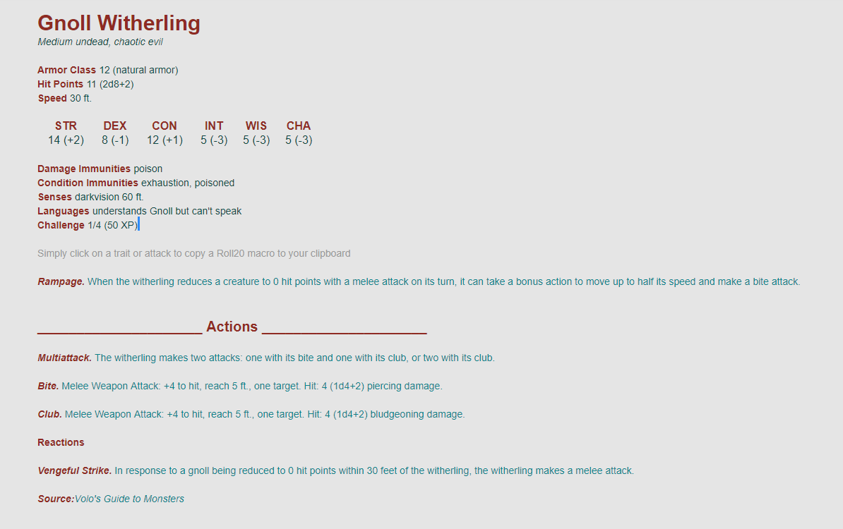

The dragonborn clans in the desert of dragons frequently move around the desert, staying in one place for merely a night or two.

However, Maystan exists as a central and permanent city adjacent to a beautiful Oasis. It is about half a day’s walk from where you are.

The city is absolutely beautiful. The clay brick houses are built around a large blue pond. Green palm trees provide shade and beauty.

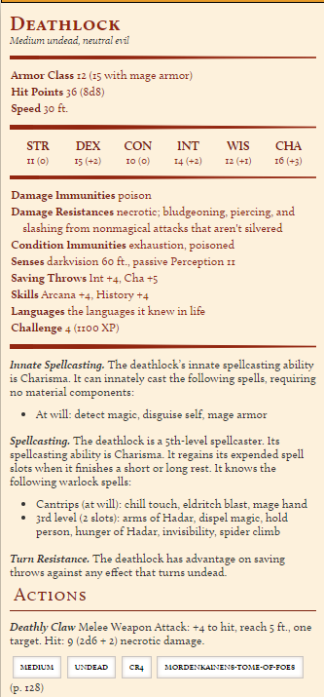

### Temple Ruins

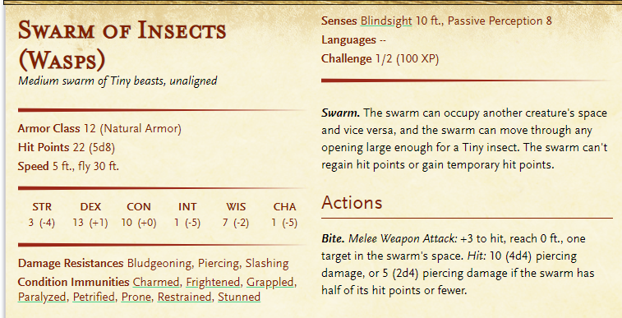

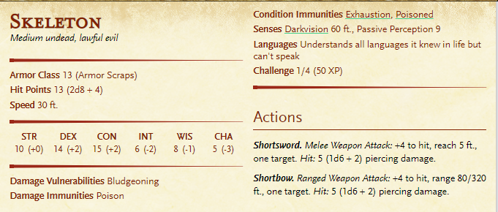

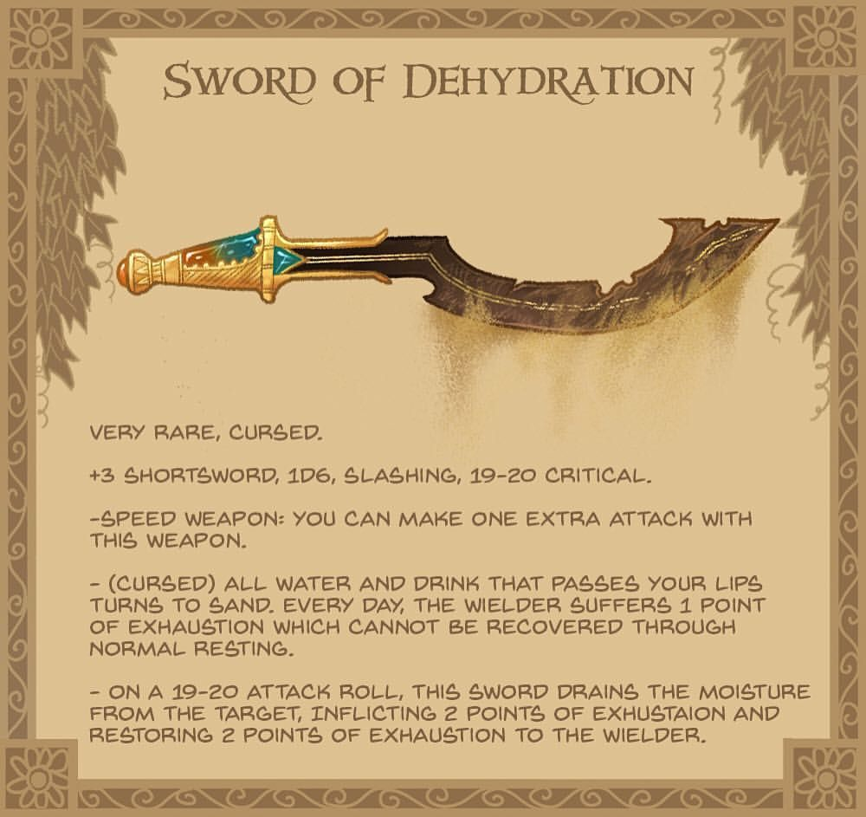

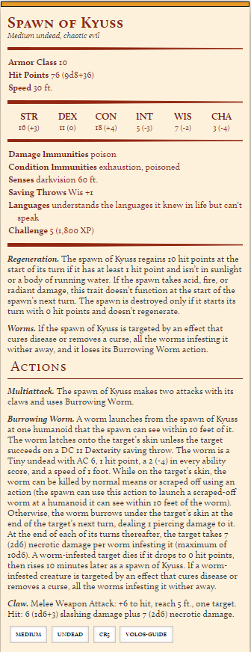

A gynosphinx can turn back time

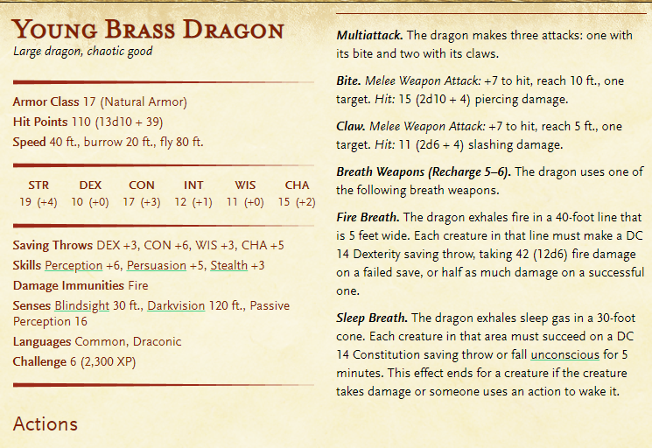

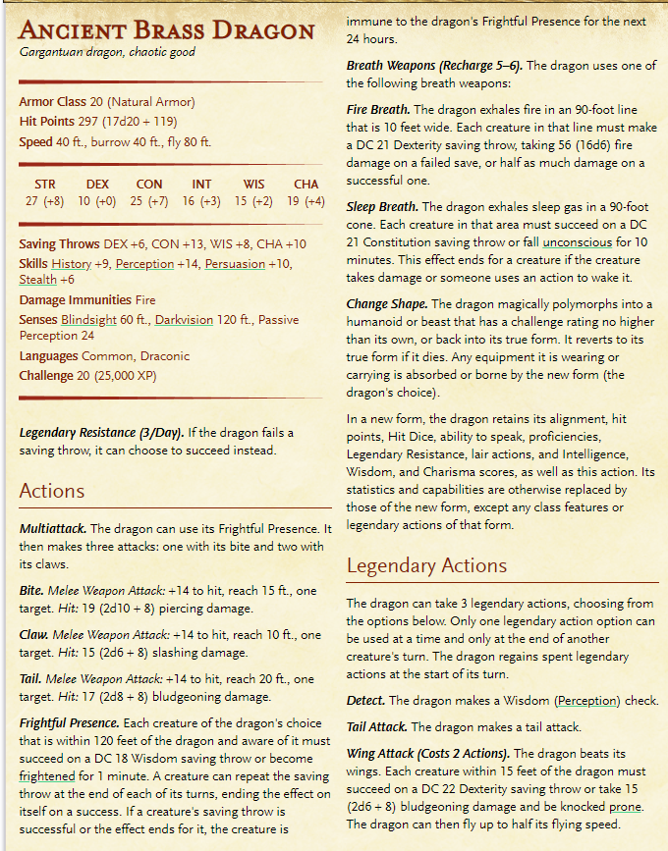

### A Brass Dragon’s Lair

#### Amarath

A brass dragon’s desert lair is typically a ruin, canyon, or cave network with ceiling holes to allow for sunlight.

#### Lair Actions

On initiative count 20 (losing initiative ties), the dragon takes a lair action to cause one of the following effects:

* A strong wind blows around the dragon. Each creature within 60 feet of the dragon must succeed on a DC 15 Strength saving throw or be pushed 15 feet away from the dragon and knocked [prone](https://www.dndbeyond.com/compendium/rules/basic-rules/appendix-a-conditions#Prone). Gases and vapors are dispersed by the wind, and unprotected flames are extinguished. Protected flames, such as lanterns, have a 50 percent chance of being extinguished.
* A cloud of sand swirls about in a 20-foot-radius sphere centered on a point the dragon can see within 120 feet of it. The cloud spreads around corners. Each creature in it must succeed on a DC 15 Constitution saving throw or be [blinded](https://www.dndbeyond.com/compendium/rules/basic-rules/appendix-a-conditions#Blinded) for 1 minute. A creature can repeat the saving throw at the end of each of its turns, ending the effect on itself on a success.

#### Regional Effects

The region containing a legendary brass dragon’s lair is warped by the dragon’s magic, which creates one or more of the following effects:

* Tracks appear in the sand within 6 miles of the dragon’s lair. The tracks lead to safe shelters and hidden water sources, while also leading away from areas that the dragon prefers to remain undisturbed.
* Images of Large or smaller monsters haunt the desert sands within 1 mile of the dragon’s lair. These illusions move and appear real, although they can do no harm. A creature that examines an image from a distance can tell it’s an illusion with a successful DC 20 Intelligence ([Investigation](https://www.dndbeyond.com/compendium/rules/basic-rules/using-ability-scores#Investigation)) check. Any physical interaction with an image reveals it to be an illusion, because objects pass through it.
* Whenever a creature with an Intelligence of 3 or higher comes within 30 feet of a water source within 1 mile of the dragon’s lair, the dragon becomes aware of the creature’s presence and location.

If the dragon dies, the tracks fade in 1d10 days, but the other effects fade immediately.